[1]

Lab 6 – Voltage Sensor Amplifiers

Farbod Jahan, Anahit Sarao, CmpE 110 Spring 2015, Lab Section 2

*Abstract*—The purpose of this report is to observe and analyze the behaviors of operational amplifiers. We were instructed to choose appropriate resistor values to achieve different voltage gains including -10, +10, & 1. The later half of the experiment includes the design of a voltage sensor amplifier with signal and reference inputs and also a summation amplifier with 2 sensor inputs.

# INTRODUCTION

During this lab we had five different circuit setups to build and analyze. The first two experiments involved an amplification of -10 & +10. We tested the operational amplifier with different input frequencies and measured the gain in each case. The third experiment was an isolation circuit with a unity gain, which is a gain of 1. Again, we tested with different input frequencies and measured the gain in each case. The fourth design was a voltage sensor amplifier with signal and reference inputs. This type of circuit output an amplification according to the difference in the signal and reference input. Different ratios of the signal to reference input were used where we measured the gain in each case. The last circuit was a simple summation amplifier where two inputs were used and the gain is seen in the output amplification.

# EXPERIMENT

*Part 1: Design a voltage sensor amplifier with an*

*amplification of -10*

We built the circuit as shown in Figure 1, but first by choosing appropriate resistor values for R1 and R2 so that the amplification is -10. This was done with the formula in (1). In this circuit, we chose R1 to be 1K and R2 to be 10K. The input voltage supplied was a sinusoidal wave at 1KHz with a 0.1V peak to peak value. The operational amplifier used was LM324 with +5V and -5V power supplied. The voltage gain was measured, which can be seen in Table I. These steps were repeated with input frequencies of 10KHz, 100KHz, and 1MHz. As you can see, when the input frequency is increased the gain is decreased when it approaches 100KHz. In Figure 4 and Figure 5 on the next page, notice the phase shift in the vout. There is a shift in time with respect to the input voltage supplied. For the last instructed exercise we were required to swap connections at the input of the operational amplifier. The results can be seen in Figure 6. Notice the straight line and constant amplification of 2V while the input voltage is 100mV peak to peak.

(1)

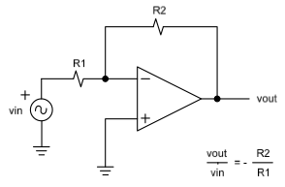

Figure 1. Circuit schematic for Part 1 voltage sensor amplifier with amplification of -10

**

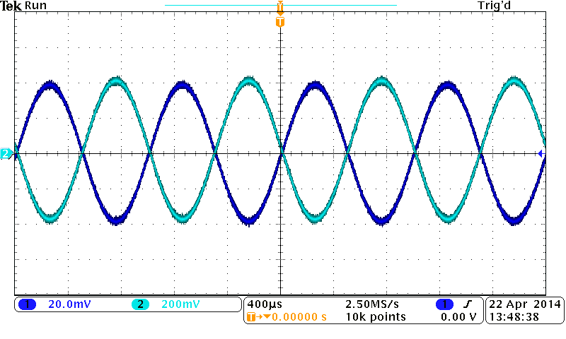

Figure 2. Waveform - 1KHz with -10 gain

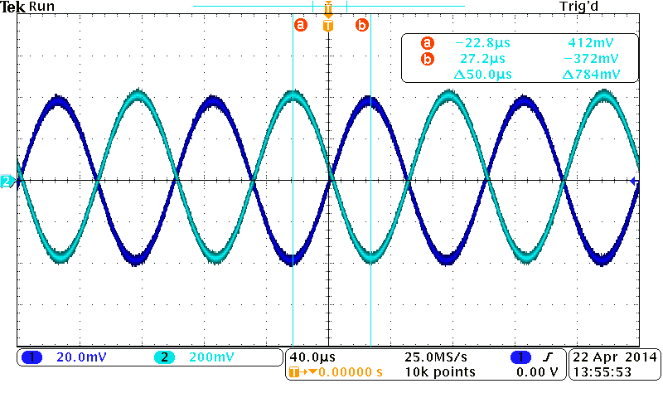

Figure 3. Waveform - 10KHz with -10 gain

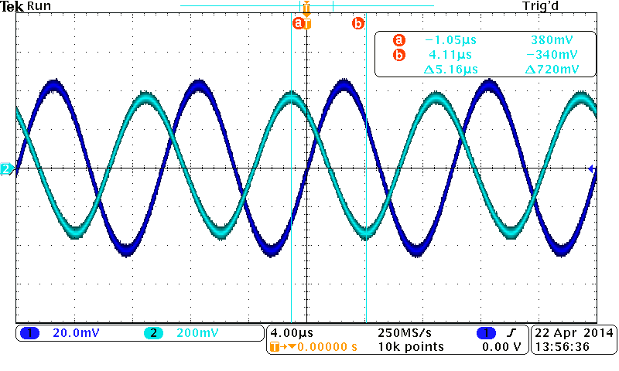

Figure 4. Waveform – 100KHz with -10 gain

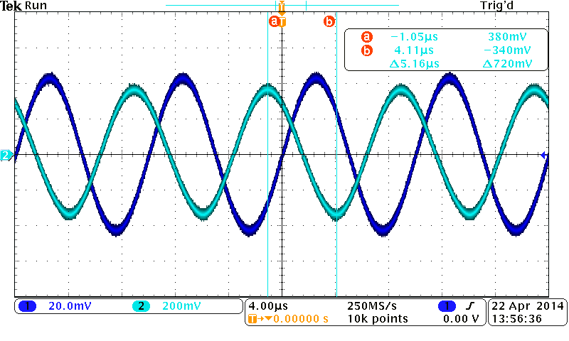

Figure 5. Waveform - 1MHz with -10 gain

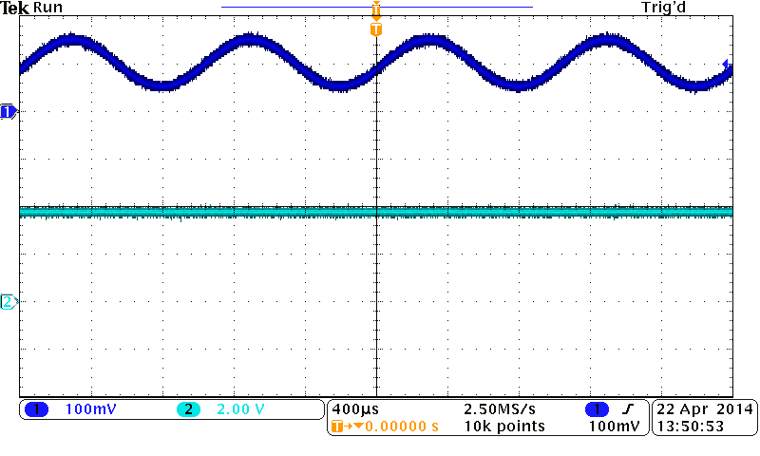

Figure 6. Waveform – Swapped connections of amp inputs

*Part 2: Design a voltage sensor amplifier with an*

*amplification of +10*

We built the circuit as shown in Figure 7 where the amplification was +10. The input voltage supplied was sinusoidal with starting frequency of 1KHz and 0.1V peak to peak. The same LM324 operational amplifier was used with +5V and -5V power supplied. Resistor values had to be calculated by using (2). We chose R1 to be 1K and R2 to be 10K. Voltages measured as well as the calculated gain can be seen in Table II. Amplification is shown to be +10 in Figure 8 and Figure 9 with input frequency of 1KHz and 10KHz. As the frequency reaches 100KHz and 1MHz, there is a phase shift and a decreased gain. With an input frequency of 1MHz, the phase shift actually results in an amplification of -10 with respect to vin. Last, when the input connections of the operational amplifier are swapped there is a constant amplification of 2V with a 50mV peak-to-peak input voltage.

(2)

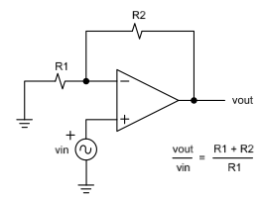

Figure 7. Circuit schematic for Part 2 voltage sensor amplifier with amplification of +10

**

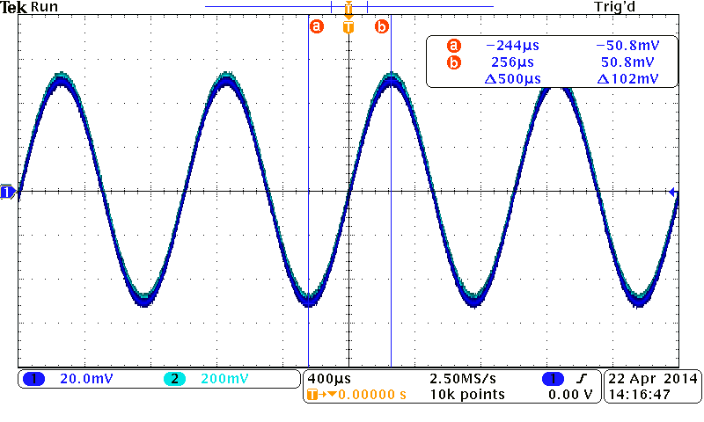

Figure 8. Waveform – 1KHz with +10 gain

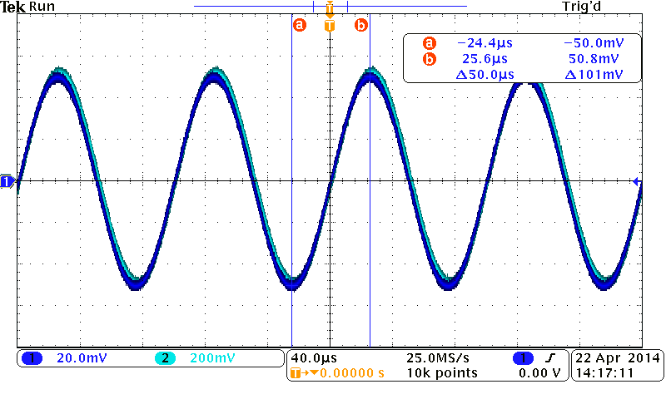

Figure 9. Waveform – 10KHz with +10 gain

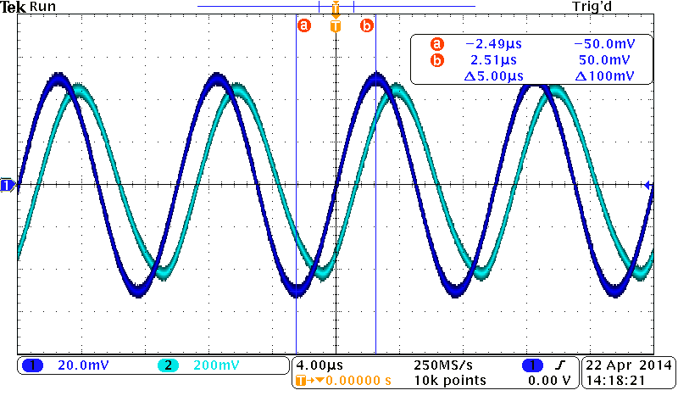

Figure 10. Waveform – 100KHz with +10 gain

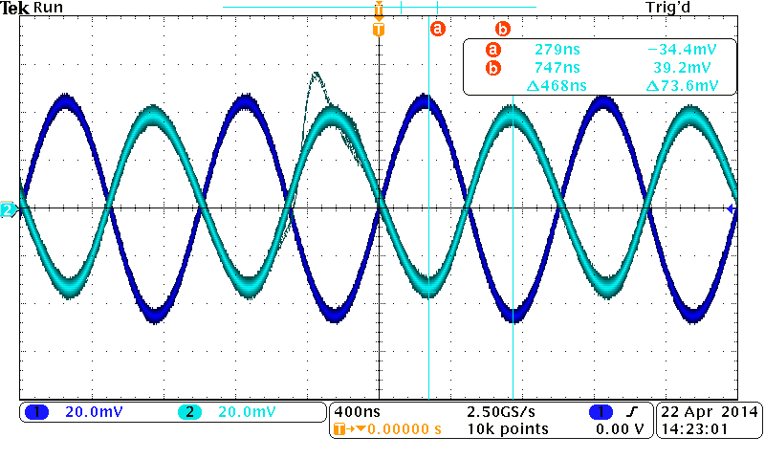

Figure 11. Waveform – 1MHz with +10 gain

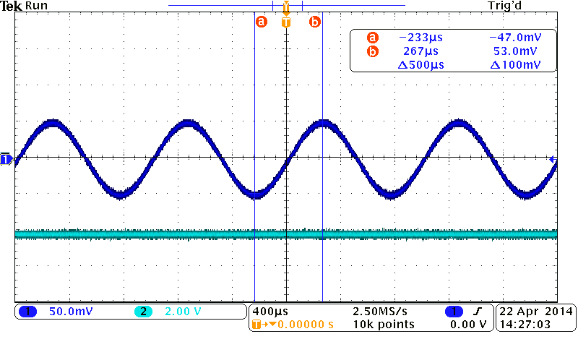

Figure 12. Waveform swapped connections of amp inputs

*Part 3: Design input/output isolation circuit with unity gain*

The isolation circuit with unity gain was built as shown in Figure 13, where input voltage started at 0.5V and was increased to 1V and 2V while oscillating at 1KHz. The input frequency was increased to 10KHz, 100KHz, and 1MHz for each input voltage. The results of vout are seen in Table III. By speculation, it can be seen that as the frequency approaches 1MHz the gain at vout is decreased. A visual representation of this behavior is seen in Figure 15 and Figure 16. Last, when the input connections are swapped the output gain at vout is a constant 2V, which can be seen in Figure 17. The input voltage is 500mV peak to peak.

(3)

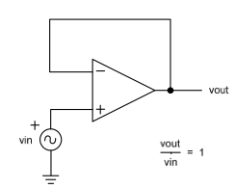

Figure 13. Circuit schematics for Part 3 isolation circuit with unity gain



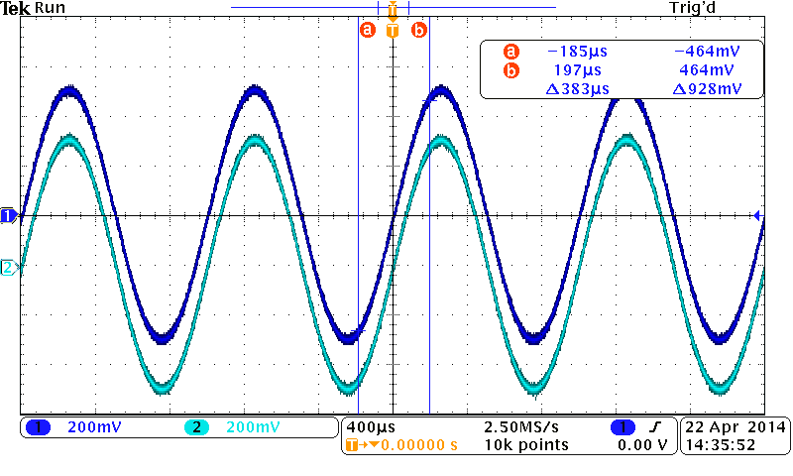

Figure 14. Waveform – unity gain

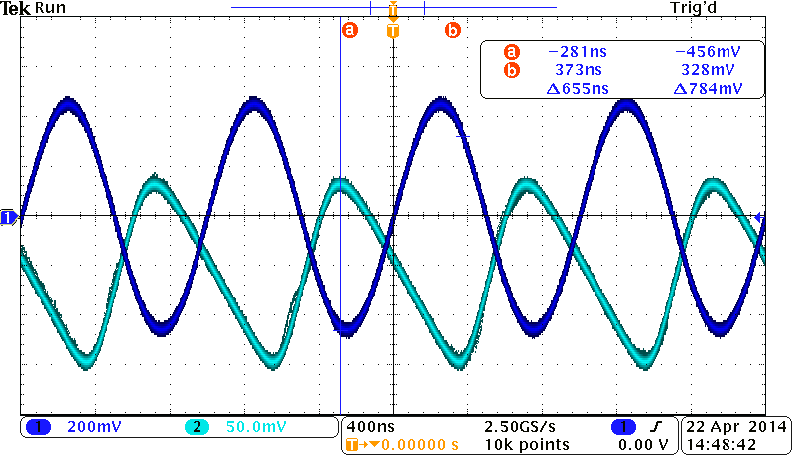

Figure 15. Waveform when vin=1V & 1MHz

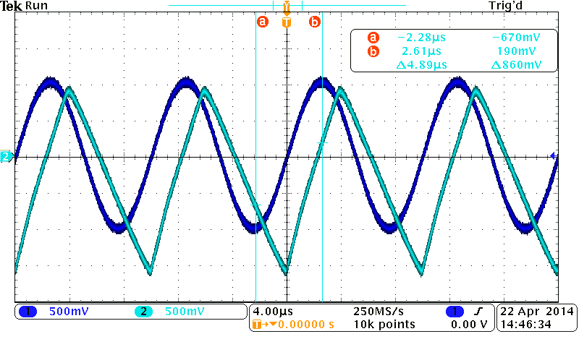

Figure 16. Waveform when vin=2V & 100KHz

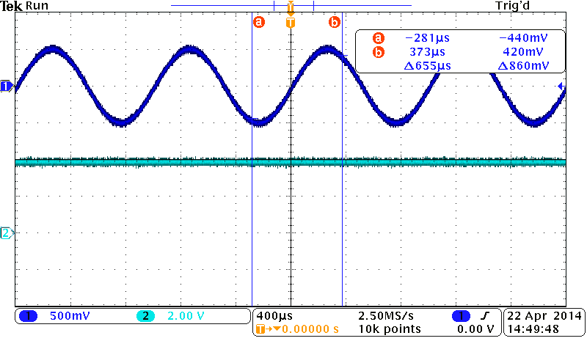

Figure 17. Waveform of swapped connections of unity gain amp

*Part 4: Design a voltage sensor amplifier with*

*signal and reference inputs*

The circuit was built as in Figure 18. Vref was generated at 25% of Vsig, 50% of Vsig, and 100% of Vsig. The circuit for Vref was shown in Figure 19, and the formula for Vref was shown below (4). We measured Vout in three cases, and the values of resistors with the results of three cases were shown respectively in table IV, V, and VI. The result waveforms were shown from Figure 20 to Figure 24.

(4)

(5)

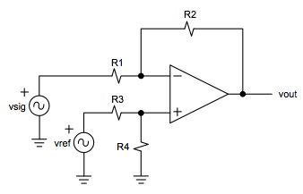

Figure 18. Circuit schematics for Part 4 voltage sensor amplifier

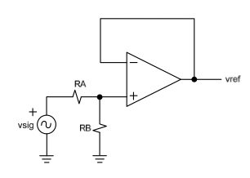

Figure 19. Circuit schematics for Part 4 vref signal







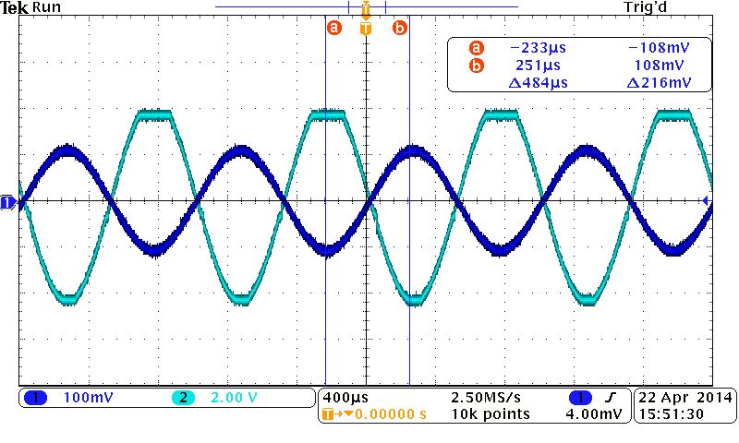

Figure 20. Waveform of vref vs. vout of sensor amplifier with sensor inputs where vref = 0.75vsig

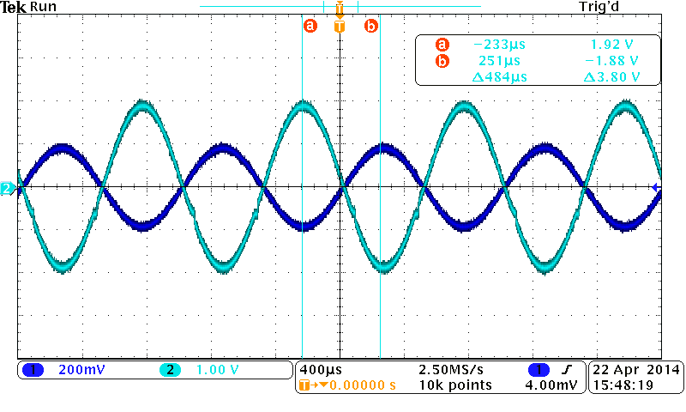

Figure 21. Waveform of vref vs. vout of sensor amplifier with sensor inputs where vref = 0.50vsig

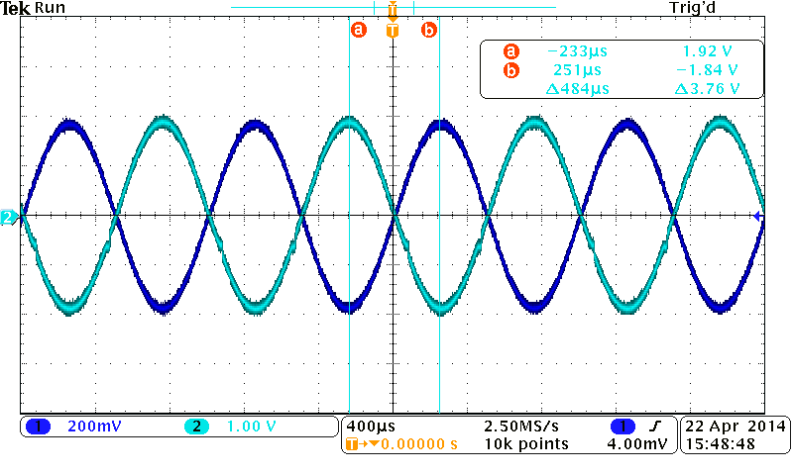

Figure 22. Waveform of vsig vs. vout of sensor amplifier with sensor inputs where vref = 0.50vsig

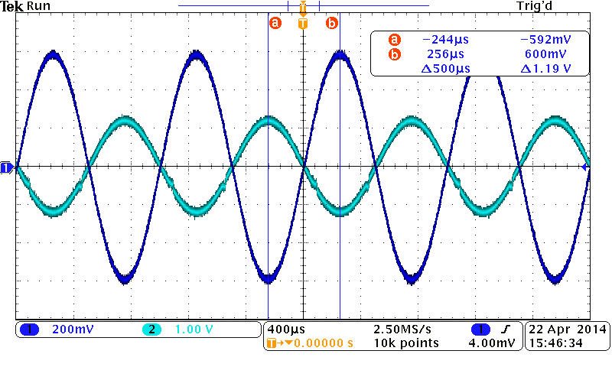

Figure 23. Waveform of vsig vs. vout of sensor amplifier with sensor inputs where vref = 0.25vsig

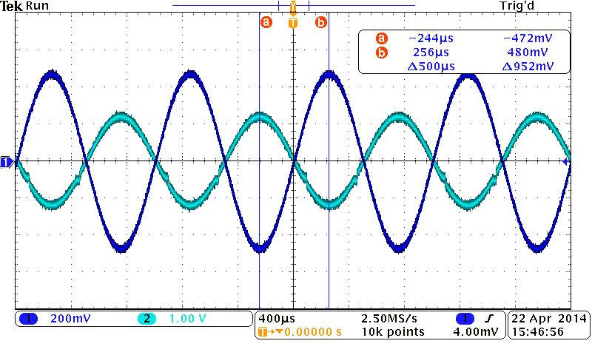

Figure 24. Waveform of vref vs. vout of sensor amplifier with sensor inputs where vref = 0.25vsig

*Part 5: Design a summation amplifier with 2 sensor inputs*

The circuit for summation amplifier was built as in Figure 24. Vin2 was generated at 25% of Vin1, 50% of Vin1, and 100% of Vin1. The circuit for Vin2 was similar to Figure 19. We used 1KΩ resistors in our circuit. Then we measured Vout in three cases, and the measurement results of three cases were shown in table VII. The result waveforms were shown from Fig.26 to Fig.28.

(6)

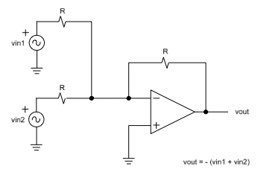

Figure 25. Circuit schematics for Part 5 summation amplifier



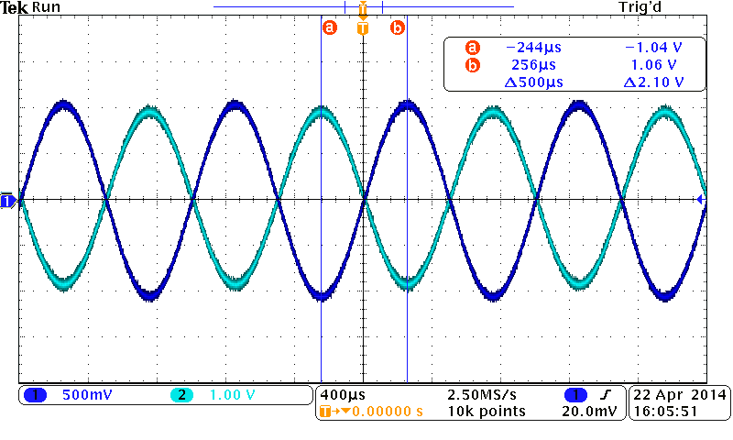

Figure 26. Waveform – Summation amplifier where

vin2 = 0.57vin1

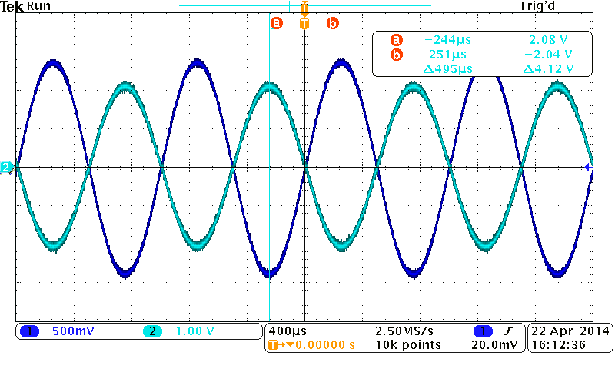

Figure 27. Waveform – Summation amplifier where

vin2 = 0.5vin1

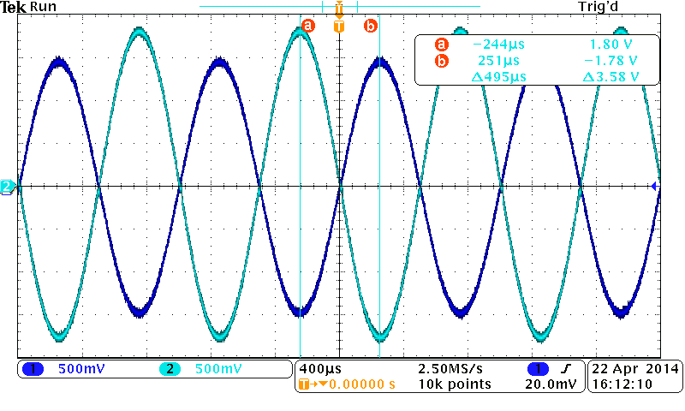

Figure 28. Waveform – Summation amplifier where

vin2 = 0.25vin1

# Conclusion

*Part 1 & 2: Design a voltage sensor amplifier with an*

*amplification of -10 & +10*

Since Part 1 and Part 2 are similar, except with the difference in magnitude of the amplification, we combined the conclusion for the two. During these two exercises, we practiced choosing resistor values to achieve a certain valued amplification. For both cases, it was observed that when the input frequency supplied to an operational amplifier is increased, there comes a point when the gain at the output of the amplifier phase shifts. Conceptually, this just results in a delayed response in amplification, as well as a decreased gain.

*Part 3: Design input/output isolation circuit with unity gain*

During this experiment, an isolation with unity gain performs exactly as expected until the input frequency is high. The amplification is 1 until the frequency is 1MHz, where the amplification is decreased and the output voltage is phase shifted with respect to the input voltage. When the input connections of the operational amplifier are swapped, this results in a constant amplification.

*Part 4: Voltage sensor amplifier with signal and reference inputs*

During this experiment, our circuits performed as expected even though we had small differences between theoretical and measurement results (varied from 2.6% to 14.2% in difference.) The reason of the differences might be because theoretical calculation always assumes the voltage difference between the positive and negative inputs to be zero and the current flowing into these two outputs to be zero. However, when we deal with the realistic circuits, there are always small differences between two inputs of the op amp and small currents flowing to the inputs.

*Part 5: Design a summation amplifier with 2 sensor inputs*

This experiment was similar to part 4 where our circuits also performed as expected and we still had small differences between theoretical and measurement results (varied from almost 0% to 4.37% in difference.) The difference between theoretical and measured was most likely because of the same reason. The op-amp circuits always have small voltage difference between the inputs and small current flowing to the inputs that are not taken into account when we perform the theoretical calculation.

1. Farbod Jahan, Anahit Sarao